K.V.G. COLLEGE OF ENGINEERING
Kurunjibhag, Sullia, D.K.-574 327, Karnataka, INDIA
E-mail: office @k website: www.kvgengg.com

Department of Chemistry

FACULTY PROFILE

Name of the Faculty |  | HONNAPA P |  |  |  |  | 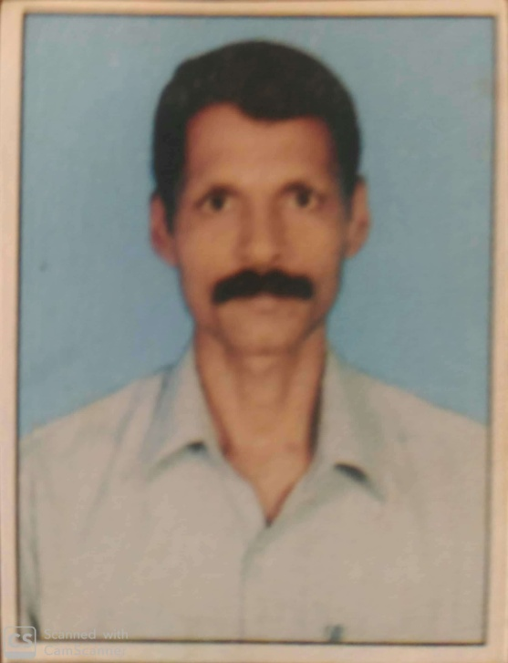
Designation |  | Sr.Attender
Contact Number
 |  | Mobile: +91–9591963680
E-mail ID |  | -------
- Educational Qualification

Qualification | Year of Passing |  |  | College & Board
S.S.L.C. | 1983 |  |  | N M High school Aranthodu
- Work Experience
Attender |  |  |  |  | Sr.Attender
10 + years’ Experience |  |  |  |  | 24+years’ Experience
- Date of Joining to the College
1st July 1988

- In-House Experience
Designation |  |  | Duration |  |  |  |  | Department
 |  |  | From |  |  | To
Attender |  |  | 1988 |  |  | 1998 |  | Chemistry
Sr.Attender |  |  | 1998 |  |  | Till the date |  | Chemistry
- Responsibilities Carried out at department and College Level
- Worked as member in stage committee of Founder’s Platinum Jubilee Celebration.
- Worked as member in food committee of department and college level functions / events.
- Worked as member in Ayudha Pooja Committee.
- Worked as attender for Student mentoring activities.
Mr. HONNAPPA P, CHEMISTRY DEPT., KVGCE, SULLIA, D.K-574327.
Reach me @ 9591963680

